## **Task 1**

**Test Case ID**

* **UI-NT.1**

**Scenario**

* **Try to create an account with invalid and missing account information and credentials**
* **Test session timeout for 20 minutes**

**Preconditions**

* Browser is open at <https://petstore.octoperf.com/actions/Catalog.action>
* New User

**Test Steps**

1. Click "Sign in” button
2. Click “Register Now!”
3. Filled User ID with “Mark Brown” and Password “fake123”
4. Intentionally left every other field blank and click “Save Account Information” button
5. Met with Error HTTP Status 500 - Internal Server Error page
6. Press browser “back” button
7. Filled out all fields (see A1 Appendix) except email with missing “@” and click “Save Account Information” button
8. Taken to Store page, click “Sign in Button”, Enter Credentials and click “login” button
9. Confirm accepted and taken to store page, click “My Account” button and verify account is there with missing “@”
10. Click “Sign Out” button
11. Followed step 1 and 2 above to get to registration page again
12. Filled out valid Account information and left User ID blank (See A2 Appendix)
13. Filled User ID with “j” and click “Save Account Information”
14. Accepted User ID, followed step 8 again.
15. Confirm accepted and taken to store page, click “My Account” and verify account is logged in with single letter “j” (see A3 appendix)
16. Click “Sign Out” button
17. Followed step 1 and 2 above to get to registration page again
18. Filled out Valid Account Information (See A4 Appendix) except password fields where I have left blank, “click “Save Account Information” button
19. Prompted to input password, thus, entered in “c” and clicked “Save Account Information” button
20. Accepted User ID, followed step 8 again.
21. Confirm accepted and taken to store page, click “My Account” button and verify account with one letter password
22. Stay on account page for 20 minutes without moving cursor or typing
23. After 20 minutes not automatically signed out
24. Click “My Order Button” and met with HTTP 500 – Internal Server Error
25. Click web browser “back” button and have been signed out

**Expected Result**

* Account creation should be rejected when:
  + Required fields are left blank.
  + An invalid email is entered (missing “@” symbol).
  + The User ID is fewer than four characters.
  + The password field is left blank.
  + The password is fewer than eight characters.
  + The session times out, requiring the user to log back in.

**Actual Result**

* Account creation was rejected in some cases:
  + Leaving all fields blank resulted in HTTP 500 with a large error dump instead of a user-friendly error message (see A5 Appendix).
  + Submitting a blank password correctly redirected the user to fill it in.
* However, account creation was unexpectedly accepted when:
  + The email was invalid (missing the “@” symbol).
  + The User ID was only one character long.
* Session timeout issue:
  + Instead of a standard session expired message, the system threw HTTP 500 – Internal Server Error.

**Summary:**

The negative test case failed, as account creation was allowed with an invalid email, a password of fewer than eight characters, and a User ID of just one character. Additionally, the system did not time out after 20 minutes of inactivity, posing a high-priority cybersecurity risk that requires review.

Error handling is inadequate, submitting an incomplete account form or experiencing inactivity results in HTTP 500 errors which is not user friendly or a way to navigate back to the home screen. A confirmation prompt when leaving the password field blank would be recommended.

**Appendix**

A1. Invalid email

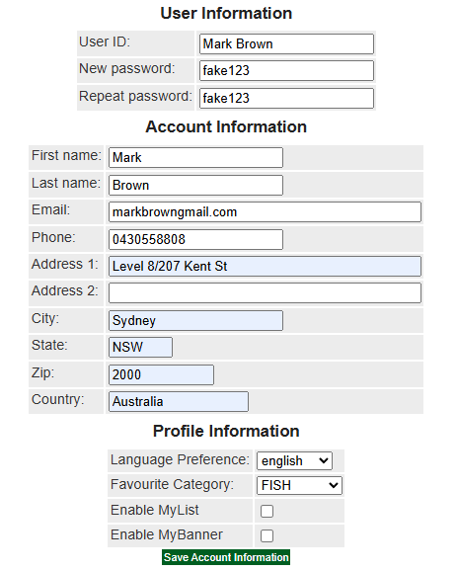

A2. Valid Account Information

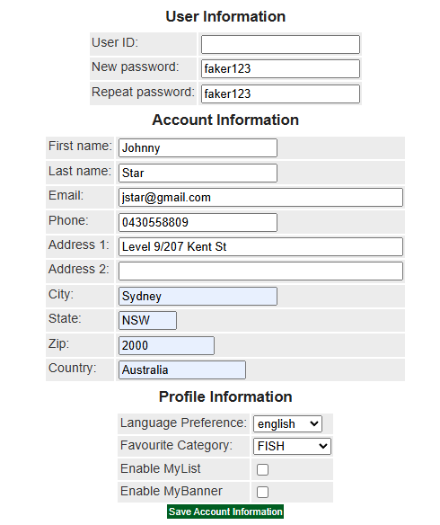

A3. Account with one letter User ID

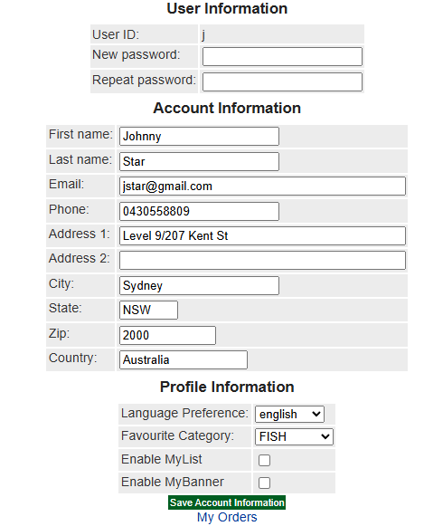

A4. Account Creation using Claudia and blank password field

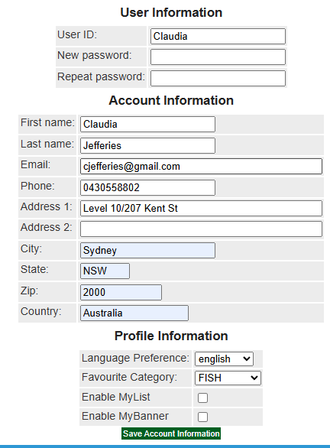

A5. Part of HTTP Status 500 - Internal Server Error

